

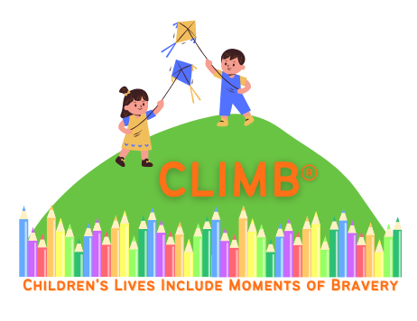


CLIMB® Programme Calendar
Start Date | Location Details | Morning/  Afternoon/ Evening | In person/  Online  Delivery
20th February 2026  28th February 2026 | ARC Cancer Support Centres  Dublin  info@arccancersupport.ie  01 215 0250 | Morning | In person
May 2026 | Cancer Care West  Galway City  091 540 040  support@cancercarewest.ie | Morning | In person

More programmes will be added to this calendar as they are announced.

